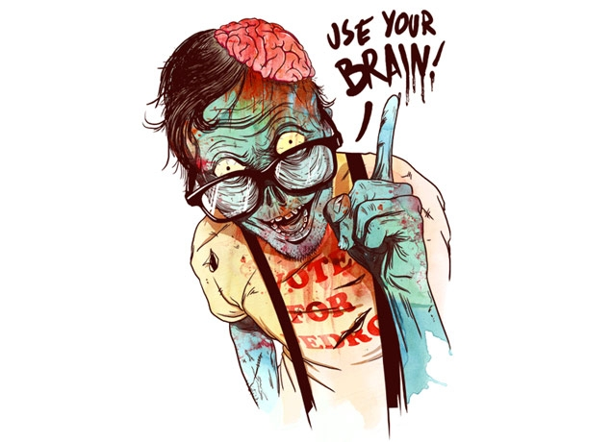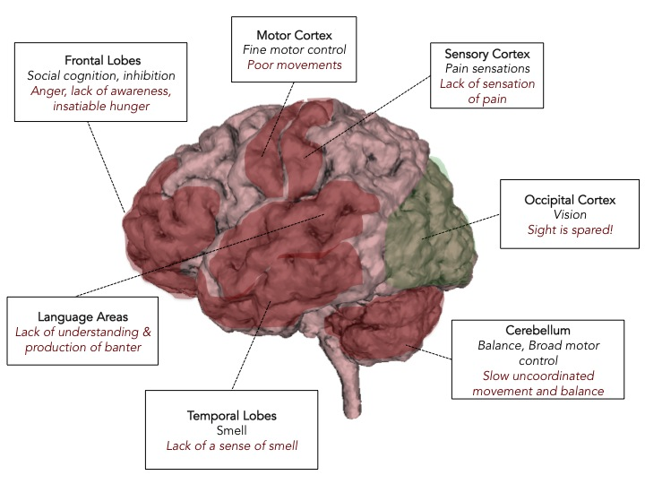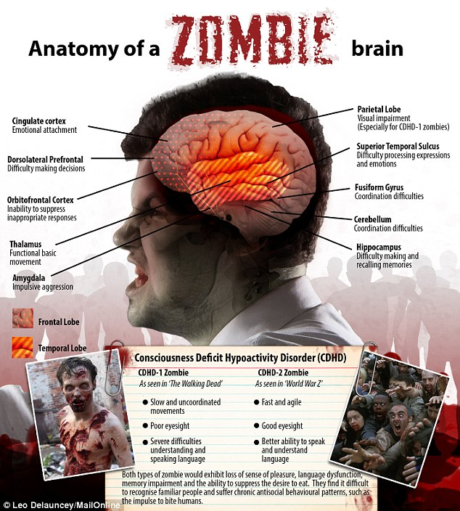Name: _____________________

Date: ______________________

Grade: _______

Vocabulary Notes:

* *Basal Ganglia: _________________________________________
* *Cerebellum: ____________________________________________
* Language Networks: ___________________________________
* Arcuate Fasiculus: ______________________________________
* Parkinson’s Disease: ___________________________________
* Ataxia: ___________________________________________________
* Aphasia: _________________________________________________
* *Amygdala: _____________________________________________
* *Hippocampus: _________________________________________
* Papez Circuit: ___________________________________________

Identify the parts of the human brain marked with the “*” using the zSpace Virtual Reality Computer